SmartLocker

Benjamin Long

CS 122A Fall 2017

**Phase I** **2**

Introduction 2

Components (Pin-out) 2

70 - 80 points project 3

80 - 90 points project 3

90 - 100 points project 3

**Phase II** **4**

Milestone 4

Testing and Verification 4

Form Factor 4

# Phase I

## Introduction

I am building SmartLocker to eliminate the hassles that come along with using a regular locker that requires a lock and key. Each time I go to the gym, I have to bring my own physical lock and key. I occasionally forget my lock at home, lose my key, or even forget which locker I used. With SmartLocker, I will never have to encounter these nuisances again.

SmartLocker is a locker security system that allows a user to create a password pattern via joystick and assign that pattern to any available locker. After setting up their locker, the user can unlock their locker by just selecting their name on the display, and inputting their pattern. If inputted correctly, their locker should automatically open. This locker security system can be deployed in commercial gyms, high schools, beaches, and many outdoor recreation centers.

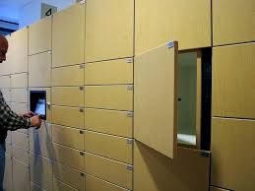

## Components (Pin-out)

* **Inputs**
  + Analog Joystick
  + Buttons
* **Outputs**
  + LCD Display
  + Stepper Motors
  + LEDs
* **Internal components**
  + HC-05 Bluetooth Module
  + Shift Registers(possibly)
* **Microcontrollers/Processors4**
  + Two Atmega1284P Microcontrollers

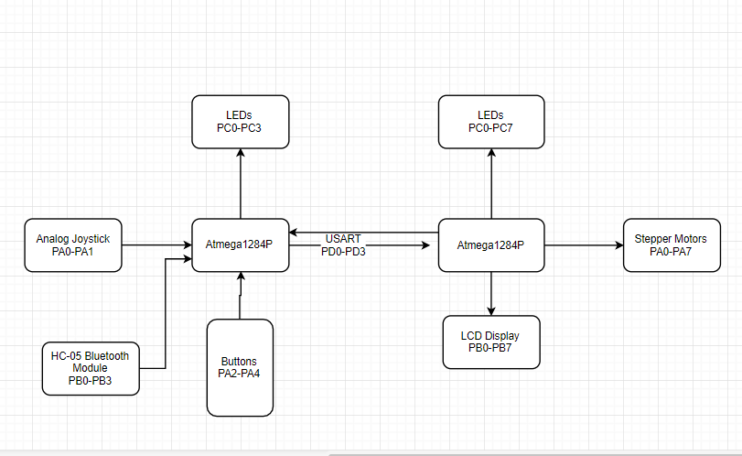

## 70 - 80 points project

What will you be doing to get your 70 - 80 implementation points. This is your base project to which you will be added additional functionality in terms of new software and/or hardware. What is the bare minimum you need to demo your concept.

To get my 70-80 points, I will have to implement all of the code and get my security system functions working properly. This includes the ability to dynamically assign lockers and password patterns to people profiles. When a correct pattern is inputted, a motor should activate to release a locker door. The display and user interface should also be fully implemented as well. If a user forgets their pattern, then they must select the “Forgot password” option and seek help from an admin. If a password has been inputted incorrectly too many times, then the locker will freeze and not open.

## 80 - 90 points project

What will you be adding to reach that 80 - 90 points. What additional component (software or hardware) will you be adding, why is this sufficient to get you the additional “10” points.

To get my 80-90 points, I will be adding a bluetooth module to allow bluetooth functionality to the system. The system will be able to be armed and disarmed through a mobile device possessed by a locker admin. There will also be an admin mode which allows the admin user to open any locker, or permanently freeze all lockers. Admin mode will have the ability to even change passwords incase a user forgot their password. Admin user accounts will never freeze.

## 90 - 100 points project

What will you be adding to reach that 90 - 100 points. What additional component (software or hardware) will you be adding, why is this sufficient to get you the additional “10” points.

To get my 90-100 points, I will be adding user function limitations. Because lockers may become limited, users may only rent out their locker for a limited amount of time so that other users may use the lockers. If a locker has reached its time limit and has not retrieved their belongings, then the locker will freeze, prompt the user to seek the front desk where they will be fined. A user can also check how much time they have remaining if they decide to return to their locker and not retrieve their belongings.

# Phase II

## Milestone

**What** is your target milestone? **When** is your intended milestone date (non-binding).

My target milestone is to have my display, lockers/motors, and locker security system functioning. The display’s menu options such as “New Locker,” “Unlock Locker,” and “Forgot Pattern” should be working fully, if not to a functioning degree. The motors should release a locker door when intended to, and should not when a password is incorrect. Admin mode should also be implemented as well(not via bluetooth but on through regular system interface) in order to properly manage the security system.

## Testing and Verification

**What** is your plan to test your invention? **How** will you test each “point level” in your project? **When** will you start testing each stage. Specifically what do you plan to do to test each stage, and who are you going to have test each stage? This doesn’t need to be the name of a person, but more a general who. For example:

* 70 - 80 point project
  + Tested by a random student in my CS122A lab
  + Tested by my lab TA
    - Test user interface and locker system functionality that includes locker assignment, password creation, and locker unlock
* 80 - 90 point project
  + Tested by a friend outside of CS122A.
    - Test out Admin mode via Bluetooth by allowing them to play as an admin through a mobile device. This exercises admin powers such as freezing, unlocking, and password changing.
* 90 - 100 point project
  + Tested by a friend outside of Engineering major.
    - They will interact with SmartLocker, test out the locker user limitations, and try to find ways to break and improve the system

## Form Factor

This is the non-engineering portion of the proposal/project. **IF** you were to make a case for your project, embed it in the environment, or “deploy” it in some fashion. What would that look like? Would you need to shrink the form factor down before deployment? Could you 3D print a case? Could you build one from wood?

**NOTE:** This is not required for this course, but presentation is still important, and it is something to think about doing before you take a project in to an interview.

I would case my project behind a nice LCD display, and place my project inside a locker wall. The screen and user interface buttons/joystick will be displayed on the outside on the locker walls. For the sake of this project, I can 3D print a miniature locker wall and utilize one of the locker spots to encase my project and display in. If my project were to be deployed as a company product, then the lockers would be fairly larger and preferably made out of metal.